**ROBOTIC PROCESS AUTOMATION**

A MINI PROJECT WORK

Submitted in Partial fulfillment of the award of Degree of Bachelor of

Technology in Mechanical Engineering

Submitted by

Vadlamudi Srikanth (17H61A03P6)

Bandlamudi Muralidhar (17H61A03J6)

Chennuri Mohith Bharadwaj (17H61A03K3)

Under the Supervision of

R. Naresh Kumar

Department of Mechanical Engineering



ANURAG GROUP OF INSTITUTIONS

(An Autonomous Institution)

(Approved by AICTE, accredited by NBA & Affiliated to JNTU, Hyderabad)

Venkatapur(V) Ghatkesar (M) RangaReddy (Dist.), Telangana 500088

May,2021

ANURAG GROUP OF INSTITUTIONS

(An Autonomous Institution)

Venkatapur(V) Ghatkesar (M) RangaReddy (Dist.), Telangana 500088.

Department of Mechanical Engineering

CERTIFICATE

This is to certify that the work in this dissertation entitled ‘**Robotic Process Automation’** being submitted by ‘**Vadlamudi Srikanth(17H61A03P6), Bandlamudi Muralidhar(17H61A03J6), Chennuri Mohith Bharadwaj(17H61AO3K3)'** is for the partial fulfillment of the requirement for the award of Bachelor of Technology in Mechanical Engineering to Anurag Group of Institutions, Venkatapur(V) Ghatkesar (M) RangaReddy (Dist.), Telangana State, during the academic year 2020 – 2021 and is a record of bonafide work, undertaken by them.

Approved and Guided by

Signature Signature

Mr. R.Naresh Kumar Dr. S. Madhu M.E, PhD

Associative Professor Professor and Head

Department of Mechanical Engineering Department of Mechanical Engineering

External Examiner

ANURAG GROUP OF INSTITUTIONS

(An Autonomous Institution)

Venkatapur(V) Ghatkesar (M) RangaReddy (Dist.), Telangana 500088.

Department of Mechanical Engineering

DECLARATION

We **‘Vadlamudi Srikanth, Bandlamudi Muralidhar, Chennuri Mohith Bharadwaj’** are students of **‘**Bachelor of Technology in Mechanical Engineering’, pertaining to 2020 – 2021 batch, Anurag Group of Institutions, Venkatapur (V), Ghatkesar (M), RangaReddy (Dist.), Telangana State, hereby declare that the work presented in this Mini Project Work entitled **‘Robotic Process Automation’’** is the outcome of our own bonafide work and is correct to the best of our knowledge and this work has been undertaken by taking care of Engineering Ethics. It contains no material previously published or written by another person nor material which has been accepted for the award of any other degree of the university or other institute of higher learning, except where due acknowledgment has been made in the text.

**Vadlamudi Srikanth(17H61A03P6)**

**Bandlamudi Muralidhar (17H61A03L6)**

**Chennuri Mohith Bharadwaj (17H61A03K3)**

**Date:**

**ACKNOWLEDGMENT**

The authors are highly grateful to the **Dr. K. S. Rao**, Professor and Director Anurag Group of Institutions, for providing this opportunity to carry out the (Major/Minor Project) at this college.

The authors would like to express a deep sense of gratitude and thanks profusely to **Dr. S. Madhu**, Professor and Head of Mechanical Engineering, without the wise counsel and able guidance, it would have been impossible to complete the report in this manner.

The help rendered by **R. Naresh Kumar** (Internal Guide) with (his/her) guidance and encouragement is greatly helpful. It would not have been possible without his/her support.

The author expresses gratitude to other faculty members of **Mechanical Engineering** of Anurag Group of Institutions (Formerly C.V.S.R College of Engineering) for their intellectual support throughout the course of this work.

**Vadlamudi Srikanth(17H61A03P6)**

**Bandlamudi Muralidhar (17H61A03L6)**

**Chennuri Mohith Bharadwaj (17H61A03K3)**

**ABSTRACT**

Payroll and salary administration are necessary tasks within every HR department, even if there is a separate payroll team. In recent years, both have been made significantly easier with new technology, but there is still the risk of human error, and it can take hours of work to complete payday obligations. And, as everyone in HR has experienced at one point in their careers, a simple error in payroll can easily lead to disgruntled employees. By using Digital Workers, the payroll process can be virtually pain-free. With their ability to work easily across multiple systems and in tandem with your team, Digital Workers can complete the traditionally manual salary and payroll administration process effectively and accurately, ensuring your people are paid the correct amount and speeding up the monthly process that many teams dread.

**LIST OF FIGURES Page No.**

Figure 1 RPA 1

Figure 2 RPA Use-Cases 9

Figure 3 RPA Architecture 12

Figure 4 Components of RPA 14

Figure 5 RPA Life Cycle 16

Figure 6 flow of building a bot 17

Figure 7 RPA Implementation 18

Figure 8 Ui Path 22

Figure 9 Blue Prism 23

**INDEX Page No.**

**Declaration** **i**

**Acknowledgement ii**

**Abstract iii**

**List of figures iv**

**1. INTRODUCTION 1**

1.1 What is RPA? 1

1.2 Why RPA? 2

1.3 Benefits of RPA 2

**2. HISTORY 3**

2.1 History of RPA 3

2.2 Screen scrapping 3

**3. ADVANTAGES AND DISADVANTAGES OF RPA 5**

3.1 Advantages of RPA 5

3.2 Disadvantages of RPA 7

3.3 RPA use cases/applications 8

3.3.1 RPA uses cases 8

3.3.2 RPA Applications 9

**4. RPA ARCHITECTURE 12**

4.1 RPA Architecture 12

4.1.1 Application under robotic process execution 12

4.2 RPA Tools 12

4.3 Configuration management 13

4.4 Components of RPA 13

4.4.1 Recorder 14

4.4.2 Development studio 14

4.4.3 Plug in /extension 15

4.4.4 BotRunner 15

4.4.5 Control Centre 15

**5. RPA LIFE CYCLE 16**

5.1 Discovery phase 16

5.2 Solution design phase 16

5.3 Development phase 16

5.4 UAT (user acceptance tests) 17

5.5 Development and maintenance phase 17

5.6 Execute bots 17

**6. RPA IMPLEMENTATION 18**

6.1 RPA implementation 18

6.2 Keys to successful implementation 20

**7. WORKING OF RPA 21**

7.1 How does RPA work? 21

7.2 RPA tools 22

7.2.1 UI path 22

7.2.2 Blue Prism 23

7.3 Core Functionalities 23

**8. RESULT 26**

8.1 HR payroll excel automation 26

8.1.1 Project Idea 26

8.1.2 Project Objectives 26

8.1.3 Project Flow 26

8.2 Activities 27

8.2.1 Activity 1: MS excel VBO (import VBO File) 27

8.2.2 Activity 2: Creating the process object from object studio 28

8.2.3 Activity 3: Testing the process object from project study 36

8.3 Output 37

8.4 Conclusion 37

**CHAPTER 1**

**INTRODUCTION**

**1.1 What is RPA?**

RPA stands for **Robotic Process Automation.** It is the technology used for software tools that automate human tasks, which are manual, rule-based, or repetitive. Typically, it is like a bot that performs such tasks at a much higher rate than a human alone. These RPA software bots never sleep and make zero mistakes, and can interact with in-house applications, websites, user portals, etc. They can log into applications, enter data, open emails and attachments, calculate and complete tasks, and then log out.

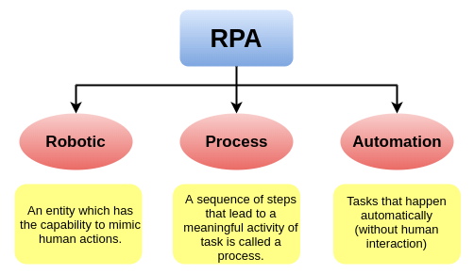

Figure 1 RPA

The term Robotic Process Automation creates a picture of physical robots doing some labor-intensive human physical tasks such as uploading or unloading heavy goods from a vehicle or cleaning the house etc. However, in reality, the picture is completely different. The word 'Robot' in 'RPA' is not a physical robot but a virtual system that helps in automating the repetitive manual computing or business process tasks.

RPA technologies can be divided into three categories:

* **Probots**

These are the bots that follow simple, repeatable rules to process data.

* **Knowbots**

These are the bots that search user-specified information from the internet and respond to the user.

* **Chatbots**

These are the bots that act and respond as virtual agents. They reply to customer queries in real-time.

## 1.2 Why RPA?

RPA is not part of an organization's IT infrastructure. Instead, it belongs to the top of the whole organization's IT infrastructure. In an IT environment, most of the business processes are not smart and intelligent. Many of them are dependent on multiple IT systems, which rarely interact with each other. Such types of tasks are repetitive, time-consuming, and labor-intensive for human beings. With the Robotic Process Automation, it takes large IT transformation plans and implementation process to automate those types of repetitive, time-consuming, and rule-based tasks more quickly, accurately, and tirelessly, compared to a human being.

RPA technology uses bots that interact with web applications, web sites, excel worksheets, and emails to automate the tasks just like a human. RPA is currently the most efficient automation solution, and it helps human beings to focus on those tasks which require emotional intelligence, reasoning, judgement, and interactions with the customers, rather than just doing repetitive tasks.

## 1.3 Benefits of RPA

Robotic Process Automation technology provides the following benefits:

### Cost Savings

### Less Error

### Faster Processing

### Better Regulatory Compliance

### Better Customer Service

### Auditable & Secure

### Low Technical Barrier

# **CHAPTER 2**

**History**

# **2.1 History of RPA (Robotic Process Automation)**

RPA is the combination of several technologies, brought together under one toolkit for different automation purposes. Though the term **'RPA'** emerged in the early 2000s, the initial development was started after the 1990s.

**'Machine Learning (ML)**' is one of those technologies that helped towards innovation, which eventually lead to the creation of RPA. In 1959, **'Arthur Samuel**' developed Machine Learning. Machine Learning allowed computers to perform several critical tasks, such as translation and text summarization, etc. However, there were limits on how computers could process language. It led to the development of **'Natural Language Processing (NLP),**' which helped computers to understand and process human language more accurately. In 1960, NLP combined **'AI (Artificial Intelligence)**' for establishing the interactions between computers and human languages. Then, the technology progressed further towards the establishment of RPA, and there were few more developments in the 1990s.

Because of the continuous developments, there was an emergence of technology that most closely resembled RPA. The history of RPA tells that there were three key predecessors of Robotic Process Automation that are given below:

## 2.2 Screen Scraping

Screen Scraping technology is considered as a significant step towards the creation of RPA. This technology is used to extract data from web, programs, and documents, which is further displayed by another application.

While there were many benefits of screen scraping over manual labor, screen scraping was also limited to some extent. Due to limitations and lack of availability of source codes, programmers, and documentation, it became difficult to understand for the average business user.

## Workflow Automation and Management Tools

Workflow automation is the process that includes a series of automated actions, which helps in reducing the human task. These actions must be repetitive so that their steps are predictable. Such actions can be automated by using automated management tools. Workflow automation uses business rules to decide when the step has been completed, and the execution of the next can be started.

## Artificial Intelligence

Artificial intelligence is the ability of computer machines or robots to perform tasks that typically require human intelligence. AI programming is based on three techniques: learning, reasoning, and self-correction.

The applications for artificial intelligence are endless and can be applied to many different sectors and industries. Some of the commonly used technologies of AI are:

* **Image Recognition -** It is the technology that identifies and detects objects or attributes in images or videos.
* **Speech Recognition -** It is the technology that identifies words and phrases in spoken language and converts them into a machine-readable format.
* **Natural Language Generation -** It is the technology that transforms structured data into natural language.
* **Sentiment Analysis -** It is the technology that uses natural language processing, text analysis, and biometrics to identify, extract, quantify, and study subjective information.

All these technologies together made RPA such an impactful technological platform and added more benefits for the business users.

# **CHAPTER 3**

# **ADVANTAGES AND DISADVANTAGES OF RPA**

Robotic Process Automation is a growing technology with several benefits. However, some people still are not convinced of it and make objections. In this article, we have addressed both sides (advantages and disadvantages) of RPA to give you a better understanding of this technology.

## 3.1 Advantages of RPA

Some of the significant advantages of Robotic Process Automation software are given below:

### **Code-Free**

RPA doesn't require any coding or programming knowledge. The modern RPA tools are used to automate applications in any department where the clerical work is performed across an enterprise. Hence, Employees only need to be trained on how RPA works, and they can easily create bots, just through **GUI (Graphical User Interface)** and different intuitive wizards. It gives an advantage over the traditional methods of automation and enables accelerated delivery of business applications. Besides, this platform reduces the initial cost of installation, training, and deployment.

### **Non-Disruptive**

One of the major challenges that IT deployment faces is the risky or complex transformation process, which prevents large organizations from redesigning, replacing, or enhancing the running system. However, the transformation process in RPA is very simple and straightforward. The RPA software robots follow the existing security, quality, and data integrity standards to access the end-user system in the same manner as human beings. These software robots also prevent disruption of any kind and maintain functionality and protections.

1. **User-Friendly**

RPA does not require a special kind of knowledge, such as coding, programming, or deep IT skills. RPA software is user-friendly, easy to understand, and easy to use. RPA tools allow users to create bots quickly and effortlessly by capturing mouse clicks and keystrokes with a built-in screen recorder component. Some of the RPA software includes the option to create and edit bots manually using the Task Editor.

### **Rich-Analytical Suite**

RPA software contains an in-built analytical suite that evaluates the performance of the robot workflows. RPA analytical suite also helps in monitoring or managing the automated functions from a central console, which can be accessed from anywhere. It offers basic metrics on robots, workflows, and more. The analysis performed by the analytical suite helps users to track the operations and determine issues. There is no need for any integration since everything is inbuilt and set right out of the box.

### **Security**

When an organization is running on automation, more users will demand access to RPA products. Therefore, it is important to have robust user access management features. RPA tools provide options to assign role-based security capabilities to ensure action specific permissions. Furthermore, the entire automated data, audits, and instructions which can be accessed by bots, are encrypted to avoid any malicious tampering. The enterprise RPA tools also offer detailed statistics of the logging of users, their actions, as well as each executed task. Thus, it ensures the internal security and maintains compliance with industry regulations.

### **Rule-based Exception Handling**

RPA system allows users to deploy bots using rules-based exception handling. This feature proactively handles the exception. For example, RPA robot reports an exception, and then the actions given below are triggered:

* The same process is re-assigned to a different bot by the server.
* The current bot retries the same process and removes the previous bot from production.
* If retry is successful, the server maintains the reassignment and raises an alert to report exception & resolution.
* If retry is unsuccessful, it stops the current bot and raises an alert to report exception as well as failed resolution.

### **Hosting and Deployment Options**

The RPA system provides deployment options across virtual machines, terminal services, and cloud. Cloud deployment is one of the best among all the other deployment options, which attracts most of the users due to its scalability and flexibility. Therefore, businesses can install RPA tools on desktops and deploy it on servers to access data for completing repetitive tasks. RPA systems can automatically deploy robots in a group of hundreds. Similarly, multiple bots can be used to run different tasks within a single process while processing a high volume of data.

### **Actionable Intelligence**

This RPA feature refers to the ability to gain and apply knowledge as skills. Robots first obtain the data and then convert it into information and transform the information into actionable intelligence for the users. Artificial intelligence and cognitive intelligence are the common features of RPA solutions that help bots to improve decision making over the period.

### **Debugging**

One of the biggest advantages of RPA from a development perspective is debugging. Some RPA tools need to be stopped running while making changes and replicating the process. The rest of the RPA tools allow dynamic interaction while debugging. It allows developers to test different scenarios by changing the values of the variable without starting or stopping the running process. This dynamic approach allows easy developments and resolution in a production environment without requiring changes to the process.

## 3.2 Disadvantages of RPA

Some of the major drawbacks of Robotic Process Automation software are given below:

### **Potential Job Losses**

If a robot can work faster with a more consistent rate, then it is assumed that there will be no need for human input. It is the main concern for the employees, and this results as a major threat to the labor market. However, this thinking is not accurate. Amazon has shown a great example of this limitation. The employment rate has grown rapidly during a period where they have increased the number of robots from 1000 to over 45000.

### **Initial Investment Costs**

RPA is still in the stage of innovation, and so it can present challenges that may result in unwanted outcomes. Therefore, it isn't easy for organizations to decide whether they should invest in robotic automation or wait until its expansion. A comprehensive business case must be developed when considering the implementation of this technology; otherwise, it will be useless if returns are only marginal, which may not worth taking the risk.

### **Hiring Skilled Staff**

Many organizations believe that to work with RPA, the staff must have significant technical knowledge of automation as robots may require programming skills and an awareness of how to operate them. It further forces organizations to either hire a skilled staff or train existing employees to expand their skills.

An automation company can be a little beneficial during initial installation and set-up.

### **Employee Resistance**

People are usually habitual, and any change in the organization may cause stress to the employees. People who are involved in new technology will get new responsibilities, and they will have to learn new concepts of a specific technology. Because everyone may not have the same level of knowledge, it may lead existing employees to resign from their job.

### **Process Selection**

It is always best to choose tasks that are repetitive, rules-based, and do not require human judgment. The non-standard processes are difficult to automate, and human interaction is required to complete such processes. So, there are limited tasks that you can automate with RPA.

# **3.3 RPA Use Cases/Applications**

There are several examples of Robotic Process Automation in our day to day tasks. In the present time, many multinational companies are using this technology to automate their day to day tasks.

By implementing RPA, these companies are getting accurate, reliable, and consistent outputs with high productivity rates.

One of the most important tasks in the Robotic Process Automation program is the right selection of business processes and activities. It ensures positive results by automating the tasks that are repetitive and rule-based.

## 3.3.1 RPA Use Cases

The following list is categorized into five different sections that display the RPA use cases:

1. Common business processes and activities
2. Activities in commercial functions
   * Sales
   * Customer Relationship Management
3. Activities in support functions
   * Tech Support
   * Technology
   * Finance
   * HR
   * Operations
   * Procurement
4. Industry-specific activities
   * Banking
   * Insurance
   * Telecom
   * Retail
5. Robotic Process applications for personal use such as digital assistants

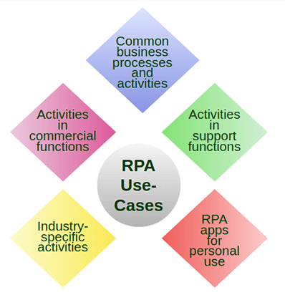

Figure 2 RPA Use-Cases

## 3.3.2 RPA Applications

There are several applications of RPA, but here, we are listing some of the common application areas:

### **Quote-to-Cash**

It is considered as an important business process, which is responsible for increasing revenue for any organization. Organizations are usually dependant on selling. If there is any issue in the operations side of selling, then it can lead to customer's complaints.

### **Procure-to-Pay**

It is the process that includes the extraction of invoices and payment data from various networks such as banks, vendors, logistics companies, etc. These networks usually do not provide easy integration methods. They generally involve manual labor to complete the tasks, which can be replaced by the RPA bots. It is the best way to fill integration gaps with a fully automated procure-to-pay.

### **Customer Onboarding**

Most of the B2C (Business-to-Consumer) organizations are following a customer onboarding process. They must maintain good relations with their customers so that customers start using their products. Using cognitive automation and OCR (Optical Character Reader), most of the customer onboarding tasks can be easily done. It can be applied even in companies that rely on legacy systems, which will help in improving the customer experience.

### **Employee Onboarding**

The process of setting up and onboarding new employees is labor-intensive and time-taking for HR and IT analysts. It includes a series of tasks such as creating new accounts, email addresses, access rights, etc. Because of the rule-based and repetitive nature of employee onboard activities, it can be automated to apply pre-defined workflow once the new user account is created. RPA bots can be assigned to send notifications and documents via email to new employees.

### **Data Migration and Data Entry**

Most companies are still using legacy systems to perform critical functions. A legacy billing system is an example of such systems. It needs to interact with other systems that may not have the capability to get required data from APIs. In such cases, employees manually perform tasks to migrate the data using formats like CSV. With the implementation of RPA, manual labor, and unexpected clerical errors, can be reduced to the minimum level. Organizations can also automate entire workflows of data entries, which can maximize productivity by reducing the time.

### **Data Validation**

RPA is more suitable than any other tools to perform data validation tasks such as checking the accuracy and quality of source data before using, importing, or processing the data. The primary aim is to create data that is consistent, accurate, and complete, so there will not be any data loss and errors during a transfer.

### **Extracting Data from PDFs, Scanned Documents and other Formats**

With technologies like Screen Scraping, OCR, and basic pattern recognition, data can be easily extracted from different formats, which will help to reduce the requirement of inputting the data manually.

### **Periodic Report Preparation**

In every business, employees need to prepare regular reports to inform managers about their work and progress. Preparing such reports and sending them to the managers may distract employees. RPA solutions can be applied to auto-generate reports, analyze their contents, and further email them to relevant managers.

### **Generating Mass Emails**

If there is a need for sending mass emails frequently, then RPA can be a great option to automate the process.

### **Creating and Developing Invoices**

Since automation is faster than manual processes, customers will get the invoices earlier, including earlier payments and improved cash-flow. The process of generating invoices and sending it to the customers can also be automated.

### **Price Comparison**

With the implementation of RPA, it is possible to keep track of the fluctuating prices. Software bots can easily create a summary of prices and also extract data for the best pricing.

# 

# **CHAPTER 4**

# **RPA ARCHITECTURE**

**4.1 RPA Architecture**

The architecture of Robotic Process Automation (RPA) includes several different tools, platforms, and various infrastructure elements. They all together form a complete RPA tool. To understand this in detail, check out the following image that gives a brief description of a typical RPA solution and its architecture:

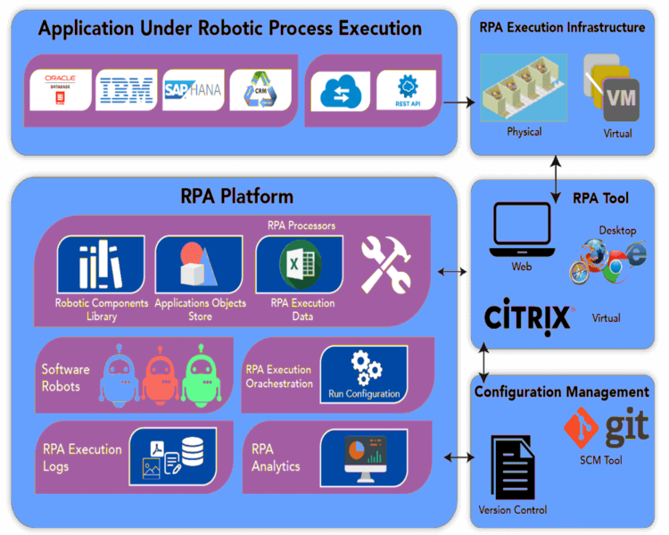

Figure 3 RPA Architecture

Let us try to understand in detail about each of the available blocks in the architecture diagram.

**4.1.1 Application under Robotic Process Execution**

RPA is considered as a well-suited technology for enterprises and enterprise applications. Enterprise applications may include SAP, Siebel, or other record processing applications like Mainframes. Such types of applications are generally data-intensive, data-centric, and loaded with repetitive tasks.

**4.2 RPA Tools**

The capabilities that are usually seen in any RPA tool are described below:

* RPA tools allow automating a variety of applications in different environments (i.e., Desktop, Web, Citrix, etc.).
* RPA tools allow developing software bots that can be trained by recordings, configuring, and enhancing the programming logic such as loops and conditions, etc.
* RPA tools allow building reusable components that can be applied to multiple robots, which ensures the same time modularity, faster development, and easier maintenance.
* RPA tools allow the reading and writing of different data sources while executing the software robots.
* RPA tools allow building shared applications, user interface object stores, and object repositories containing object locators.

RPA Platform

RPA software bots in the cloud act like they are stored in a shared repository, which can be further shared across libraries of software robots. RPA platform helps in scheduling, distributing, and monitoring the execution of software robots. It also provides the ability to develop meaningful insights of software bots and their execution statistics.

RPA Execution Infrastructure

RPA execution infrastructure is defined as a bank containing physical or virtual lab machines that can be controlled on the basis of usage patterns. The process of scaling up or down the number of machines parallelly for automating the task can also be performed. This process does not require any further human interaction, so it can be left unattended for as long as needed.

**4.3 Configuration Management**

Configuration Management is used for stating the version of RPA assets as the underlying application. It helps in developing the software robots and also updating them to newer versions. It also helps in branching and merging of RPA robots since they are reusable across the libraries.

Therefore, RPA is a combination of several different layers of applications and tools that are combined to make it a complete system and the architecture

# **4.4 Components of RPA**

Robotic Process Automation includes some essential components that form the RPA platform. These components together help to automate repetitive and rule-based processes.

The core components of Robotic Process Automation are listed below:

* Recorder
* Development Studio
* Plugin/Extension
* Bot Runner
* Control Center

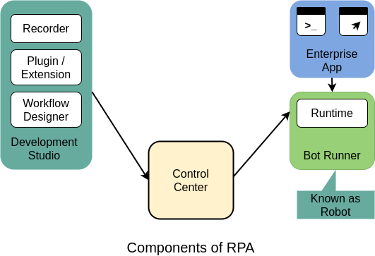

Figure 4 Components of RPA

Let's describe each of these components one by one:

**4.4.1 Recorder**

The recorder is one of the critical components of Robotic Process Automation. It adds an ability to automate web, desktop, and mainframe applications in a natural macro-like way without the need of any programming, coding or scripting.

Recorder in robotic automation uses an object recording approach as a primary mode. By default, RPA bots capture object properties, including their values of active elements throughout the recording. After the recording is complete, RPA bots find the same elements and repeat the process as they recorded. RPA robots perform actions such as click, hover, drag, or scroll, on the same elements during script execution. RPA Recorder also includes an option to modify the workflow and add the system actions manually. These actions may consist of opening applications, switching to a specific window, working with a clipboard, manipulating Excel files, etc.

**4.4.2 Development Studio**

Almost every RPA tool includes Development Studio in its core components. The Development Studio helps to design or develop intelligent process automation workflows. It allows you to get full control over the automation. It also allows you to install activities packages, wizards, recorders, and custom plugins.

Some typical features of RPA Developer Studio can be explained as below:

* Dashboard with **GUI (Graphical User Interface)**.
* Different types of Recorders.
* Logging and Exception Handling.
* Integration support with **OCR (Optical Character Reader)**.
* Collection of pre-built, drag-and-drop templates.
* Universal search option to search across all the automation resources such as libraries, activities, projects, etc.

**4.4.3 Plugin/ Extension**

Most of the RPA platforms consist of several plugins and extensions to perform easy development and execution. RPA plugins are the set of programs that can be installed along with the RPA tool. These plugins handle different types of tasks, such as extracting the data from invoices, manipulating the dates of different databases, or transcribing speech, etc. RPA plugins are beneficial as they reduce the development efforts, error rates, and implementation time. They can be directly used after they are installed along with the RPA tool.

**4.4.4 Bot Runner**

Bot Runners are used for executing the developed software bots. They are the machines on which bots are run or executed. Multiple bots can be assembled parallelly for faster execution. The only requirement to run the bots is 'Run License'. The bots also report the execution status (i.e., execution logs, pass, or fail, etc.) back to the control center. Once a developer creates a software bot or task and further updates the status on the control room, the control room schedule and executes the bots on the bot runner. The serial of bot execution usually depends on the requirements or priorities.

**4.4.5 Control Center**

The control center is the most important component of any RPA tool. It is a web-based platform that is used to control the software bots created by the Bot Creator. It allows users to schedule, manage, control, and scale the activity of a vast amount of digital workforce. It also offers features such as centralized user management, automation deployment, source control, and a dashboard.

# 

# **CHAPTER 5**

# **RPA LIFE CYCLE**

RPA Lifecycle does not have any particular defined structure. It includes different phases of the automation process, from the creation of bots to the execution of the bots. Check out the following diagram displaying all these phases:

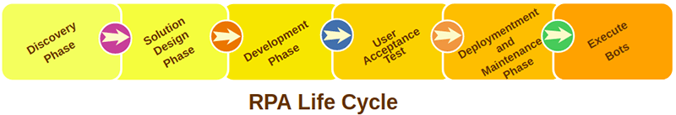

Figure 5 RPA Life Cycle

## 5.1 Discovery Phase

The discovery phase is the initial phase of the RPA lifecycle. In this phase, the RPA process architect analyzes the requirements of the client. Then it is further decided whether the process can be automated or not. If the process can be automated, then the RPA analyst team might involve the RPA architect team and analyze the complexity of the process.

## 5.2 Solution Design Phase

Based on requirements, the steps to automate the task, are designed. The RPA technical architect, in collaboration with the process architect, develop a **Process Definition Document** (PDD), which includes information about the whole process. They follow the developmental methodology and develop a strategy to automate specific tasks to reduce manual work as much as they can.

Once all the requirements are matched, the next step is to decide the budget, number of people, time to be spent on the project, etc. Then, the analyst team creates a flowchart to understand the flow of processes, which helps in choosing the right processes for automation. After the selection of processes, the RPA tool is used to start the development of bots and automate tasks.

## 5.3 Development Phase

In this phase, the RPA developer creates scripts/bots to automate the tasks with the help of RPA tools. There are several RPA tools available in the market. Automation scripts/bots are generated by following the previously developed PDD. Generally, there is no requirement for coding. But it may change depending on the tasks to be automated.

After developing the bots, the next step is to test the developed bots.

## 5.4 UAT (User Acceptance Tests)

In this phase, the RPA development team tests the developed bots. These bots are tested in a pre-production environment to examine how the users can use them to automate specific tasks. If the testing phase gets passed successfully, then it is further transferred to the next stage. Besides, if the testing fails, then it is transferred back to the development phase, where RPA developers examine errors found in the testing phase and solve them.

Once the bots get successfully tested, then they are transferred to the deployment phase of the RPA Lifecycle.

## 5.5 Deployment and Maintenance Phase

The bots are deployed into the production environment when only they have completed the development and testing phases. After the deployment process, users can use them to automate their tasks. If there is still a problem with the bots, like bots are not automating, then they are further transferred to the RPA development and testing team. The development team will again analyze the bots and resolve the problems.

## 5.6 Execute Bots

This phase includes the execution of the bots after deployment. Bots are also checked to ensure that the implementation is performed as per requirements.

The following image explains the flow of building a bot:

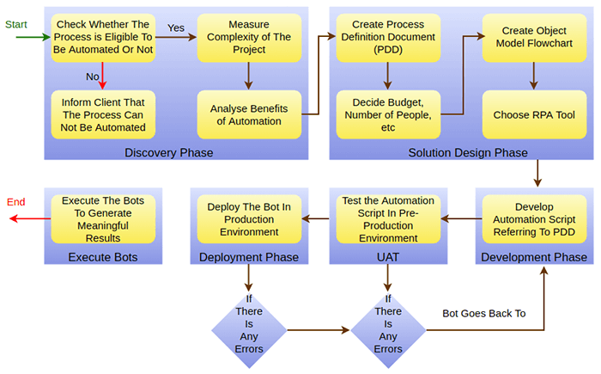

Figure 6 flow of building a bot

**CHAPTER 6**

# **RPA Implementation**

**6.1 RPA Implementation**

RPA software has provided an excellent option for corporate and shared services. It is an efficient, cost-effective alternative to traditional process approaches. RPA implementations are increasing in popularity due to the money and resources according to time. Once the organizations make sure to implement RPA, they are required to move forward with a stage-wise implementation approach.

To implement RPA successfully in an organization, the organization must use time-tested and robust methodology. RPA implementation mainly depends on the requirements of the organization. It typically includes the following stages:

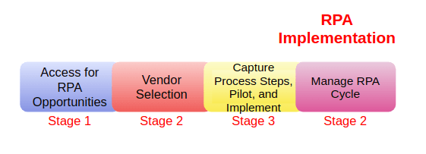

Figure 7 RPA Implementation

## Stage 1 - Access for RPA Opportunities

Organizations should find the right business processes before the implementation of RPA technology. Implementation with the right processes can be beneficial for organizations. Every process in the business may not be suitable for the RPA implementation. Therefore, organizations should conduct a high-level assessment of the potential processes and select the right processes to be automated. It will help them to decide whether RPA is a good fit for their organization or not.

Once an organization has decided to implement this technology, they should set the objectives of the RPA initiative. It will be an excellent choice to get an agreement from executive stakeholders on project objectives.

This initial stage examines which areas will get the most benefit by switching to RPA technology. It also includes technology demonstrations by selected RPA vendors to serve as a POC (Proof of Concept) and platform for knowledge gathering.

**Stage 2 - Select a Vendor**

In this phase, organizations start finding RPA vendors based on the technical requirements of the organization. The selection process is an opportunity for RPA providers or vendors to show how they meet the requirements and criteria of the organization.

Organizations invite different RPA vendors to take part in the on-site presentation and show how RPA can help with the growth of the company. Many vendors agree to demonstrate the whole presentation by applying RPA technology to the selected processes as a proof of concept.

Then, organizations select a vendor that complies with their requirements and business objectives. There are two types of implementation that RPA vendors may present:

* RPA vendors will conduct the configuration and test for the organization.
* RPA vendors will sell bot licenses and teach how to implement them.

Most vendors provide both of these services. So, it depends on the requirements of the organization to choose any of these ways for the implementation. Many businesses opt for a vendor to code the initial pilot and develop an internal RPA center of expertise to handle future implementations.

**Stage 3 - Capture Process Steps, Pilot, and Implement**

During this stage, businesses ensure whether human resources are trained and ready to execute the selected RPA implementation plan. This stage also includes the activities required to support and test the IT environment. All the implementation activities are documented, tracked, and completed as per the defined criteria.

This stage also includes the facilitation of the pilot for the selected process areas or use cases. It allows businesses to observe the effectiveness and overall performance of the automation plan with an actual process in real-time.

As per the results of the pilot project, businesses may include scenarios that need to be automated, which showcase the full extent of the RPA technology. If there is any problem, then the RPA development team analyzes and resolves it. It further establishes the groundwork for upcoming state operational models.

**Stage 4 - Manage the RPA Lifecycle**

In this stage, the initial launch of RPA is processed. This stage also includes the planning for the ongoing success of RPA software through proactive maintenance. This strategy should combine governance, operating model, organizational structure, and change management plan of the RPA solution. There should be a good change management plan to estimate the impact of change in processes and systems. So, the businesses will be able to limit the margin of error as they proceed.

**6.2 Keys to Successful Implementation**

Before implementing RPA technology, organizations should consider the following keys which will help in successful implementation:

* Select the right project team for internal and external operations.
* Execute detailed work plans to ensure that no work is dropped.
* Form quick connections with IT, controls, and procurement.
* Estimate the impact of changes in people.

# 

**CHAPTER 7**

# **WORKING OF RPA**

With the name of RPA, many people may think about physical robots performing day to day tasks. However, RPA does not use physical robots to automate tasks. It does not replace humans with actual robots. The term 'robot' in Robotic Process Automation is a software running on physical or virtual machines. Such software help in configuring automation workflows to automate business operations.

## 7.1 How does RPA work?

Robotic Process Automation is operated by running a set of workflow tasks. It provides instructions to the software bots on what to do at each stage. Once this workflow has been programmed into the RPA, the software can then automatically run the program and complete the specified task multiple times as per the requirements.

One of the most common examples of RPA is the 'automated creation of invoices'. It is an essential function for any business, but sometimes, it can be a critical task. This task is usually repetitive, and so can be time-consuming for human employees as they have to deal with hundreds or thousands of such tasks every day.

Because of being repetitive and structured, these processes are ideal to be automated with the help of RPA. In a typical business, the workflow for this process may look like the following sequence:

* A customer requests for an invoice through mail.
* The operator checks the mail and opens the relevant billing software.
* Information is copied from the email into the billing software.
* The invoice is created using the given information and saved.
* The original sender is informed that the process is complete.

All these steps can be automated with the help of the RPA tool. As soon as the customer generates an email request, all these steps will be performed automatically by RPA bots, and there will be no need for human input. Preparing and cleansing data in a structured format helps the software bots to easily copy and paste data from one field to another without oversight.

In case of incomplete, inaccurate, or missing data, these software bots can send the acknowledgment to the original sender and request for the correct data. It prevents all kinds of mistakes that may arise as a result of user error.

# **7.2 RPA Tools**

RPA tools are the software that helps users to configure various tasks to get automated. Most of the organizations have periodic and repetitive tasks such as data entry, data extraction, report generation, etc. These tasks are manually performed on the software by the employees. Such repetitive tasks can be easily automated with the help of bots. The software that utilizes bots for performing automation is called the RPA Tool

Some popular RPA tools are described below:

## 7.2.1 UiPath

UiPath is a highly extensible Robotic Process Automation tool that helps to automate desktop or web applications. It offers global enterprises to design and deploy a robotic workforce for their organizations.

The best thing about UiPath is that it includes a community edition that comes with drag and drop feature. So, the users do not need programming knowledge to automate the tasks using UiPath. The community edition is free for the people who want to learn, practice, and implement RPA.

### **Features**

* It provides multiple hosting options, such as cloud environments, virtual machines, and terminal services.
* It supports a high range of web and desktop applications.
* It supports the auto-login feature to run bots.
* It includes scrapping solution which works with .Net, Java, Flash, PDF, Legacy, SAP, with maximum accuracy.

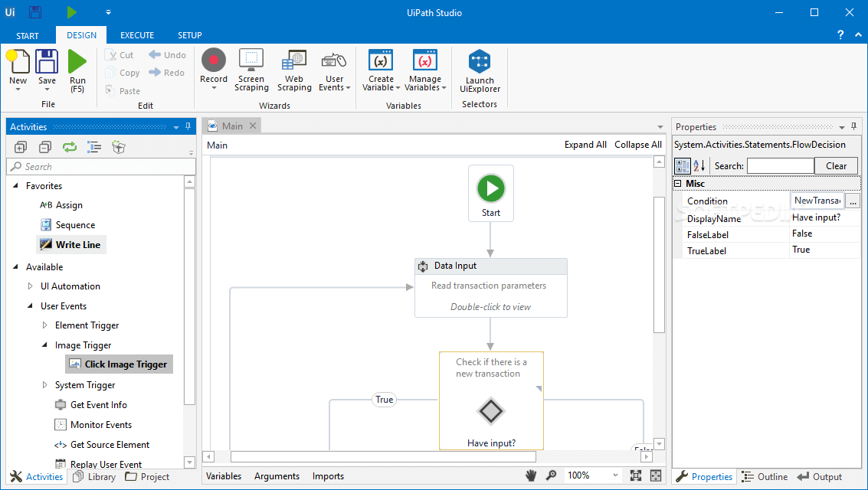

Figure 8 Ui Path

## 7.2.2 Blue Prism

Blue Prism is an RPA Tool that provides a virtual workforce to the organizations. It helps organizations to automate manual, repetitive, and rule-based business processes in an agile and cost-effective manner. It includes drag and drop support to automate the tasks.

### **Features**

* It is platform-independent so that it can be used on any platform.
* It contains robust features like load balancing, data encryption, and end-to-end auditing. Thus, every change is audited.
* Blue Prism also supports automation of codes written in Mainframe, Java, Windows applications, and even web-based applications.
* It supports all major cloud platforms, like Microsoft Azure and Amazon AWS. So, users can manage most of the tasks centrally.

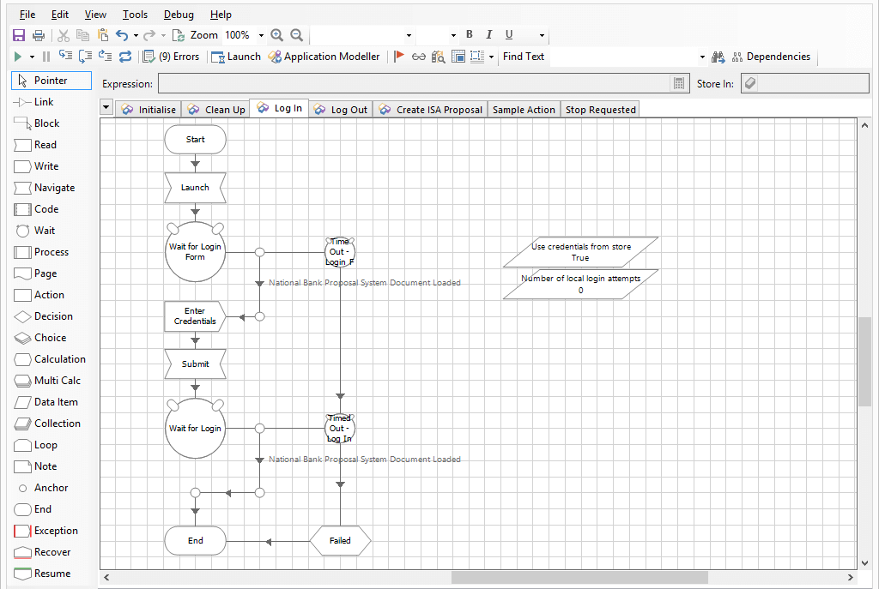

Figure 9 Blue Prism

## 7.3 Core Functionalities of RPA Tools

Following core functionalities should be present in any RPA tool:

* A software robot should be able to interact with other systems either through Screen Scraping or API Integration.
* A software robot should be capable of making decisions and determine its actions based on inputs gathered from other systems.
* A software robot should have an interface to program the other robots.

## Choosing the right RPA Tool

As we have seen, there are lots of RPA tools, but the question is which tool should we choose. Following are some parameters which should be considered before choosing the RPA tool:

### **Technology**

The RPA tool must be platform-independent and should support all kinds of applications so that the organization will be able to perform their routine tasks outside the local desktops.

There are some other important technologies (i.e., screen scraping, scalability, cognitive capabilities, etc.) that should be available in the RPA tool.

### **Scalability**

One of the important parameters of the RPA tool is scalability. There should be an option to expand the robotic workforce as per the requirements. RPA tool should support expansion for either no extra or minimal cost.

### **Security**

Security is an important parameter to be considered before the selection of the RPA tool. Since the software robots access and manage private data, the organization should check all the security features of the tool. They are required to measure all the security controls before the implementation of RPA. Otherwise, the system may become accessible to external malicious attacks. It can cause misuse of confidential data, privacy issues, and other security concerns.

### **Total Cost of Ownership**

The total cost of ownership is considered as another important parameter that should be evaluated before choosing the RPA tool. It depends on different factors such as initial setup cost, vendor fees, repetitive license fees, cost of implementation, maintenance, and more. Because the organizations usually prefer to start small and then scale, that's why the evaluation of the cost of the RPA tool with the company's RPA roadmap in mind is necessary.

### **Ease of Implementation**

The selection of the RPA tool must include easy and quick integration as per the business requirements. It is necessary to check the compatibility with existing legacy systems to enable smooth transition after the implementation.

### **Ease of Use & Control**

The RPA tool should be flexible and easy to use for performing the automation process. There should be options that can be controlled easily. It is better to use such an RPA tool, which requires less training and can be operated by users who lack knowledge in programming.

### **Vendor Experience**

Choosing an experienced vendor will drastically improve the speed of implementation and reduce the work required to implement RPA software.

### **Maintenance & Support**

It's always good to choose such RPA providers who provide strong vendor support to their clients. A good vendor support helps in getting technological innovations, smoother deployments, better training, and certifications, etc.

### **Quick Deployment**

The RPA tool should be able to help the user by interacting with applications which is available at the presentation layer. It also supports the user by validation, screens, and business rules, as they all are presented through a virtual desktop.

**CHAPTER 8**

**RESULT**

**8.1 HR Payroll Excel Automation**

**8.1.1 Project Idea:**

Need to find a new one --“Generally, in the industries monitoring the machine status continuously and maintaining the records of the entire data plays a very important role as that helps the officials to analyze the production factors. This also helps in resolving some of the problems like machine failures, production delays, etc.

Through this project, we can create a system that will capture some important parameters of the machines like their temperature, liquid level. All the parameters along with the date and time are stored in google sheets. Third-party services like IFTTT are used for publishing the data to google sheets. admin can monitor the entire device parameters and the previous records of data through the google sheets.”

**8.1.2 Project Objectives:**

By the end of this project you will:

1. Gain insights into building blocks of Blue Prism automation.
2. Importing MS Excel VBO(Visual Basic for Applications) in Blue Prism.
3. Tuning Process Studio with specific needs.
4. Working with different stages in the Process studio.
5. Build a HR Payroll Excel Automation that works over microsoft excel 2013.

**8.1.3 Project Flow:**

1. Importing Blue Prism MS Excel VBO (Visual Basic for Applications)
2. Binding Process Studio with MS Excel VBO.
3. Opening MS Excel WorkBook.
4. Specifying Blue Prism Stages to work on MS Excel WorkBook in Blue Prism.
5. Tuning Process Flow with Blue Prism Actions.
6. Closing MS Excel WorkBook.

To accomplish this, we have to complete all the activities and tasks listed below:

1. Configure the Process Model
   * Import MS Excel VBO
   * Process Model binding with MS Excel VBO
2. Adding Process Stages
   * Create Instance
   * Open Excel file
   * Get to collection
   * Loop module
   * Multi Calculation module
   * Write collection
   * Save Excel file
   * Close workbook
3. Test the Model
   * Test Process Model

**8.2 Activities:**

Milestone 1: Configure the Process Studio

Let us create the Process Object bind with MS Excel VBO.

Object studio is mainly used to develop the objects. Inside the object, we have different types of actions as follows

1. Application Modular to Spy the Elements
2. Initialize page and clean up page

**8.2.1 Activity 1: MS Excel VBO (Import VBO file)**

File -> Import -> Browse -> (C:\Program Files\Blue Prism Limited\Blue Prism Automate\VBO\BPA Object - MS Excel). Click Finish.

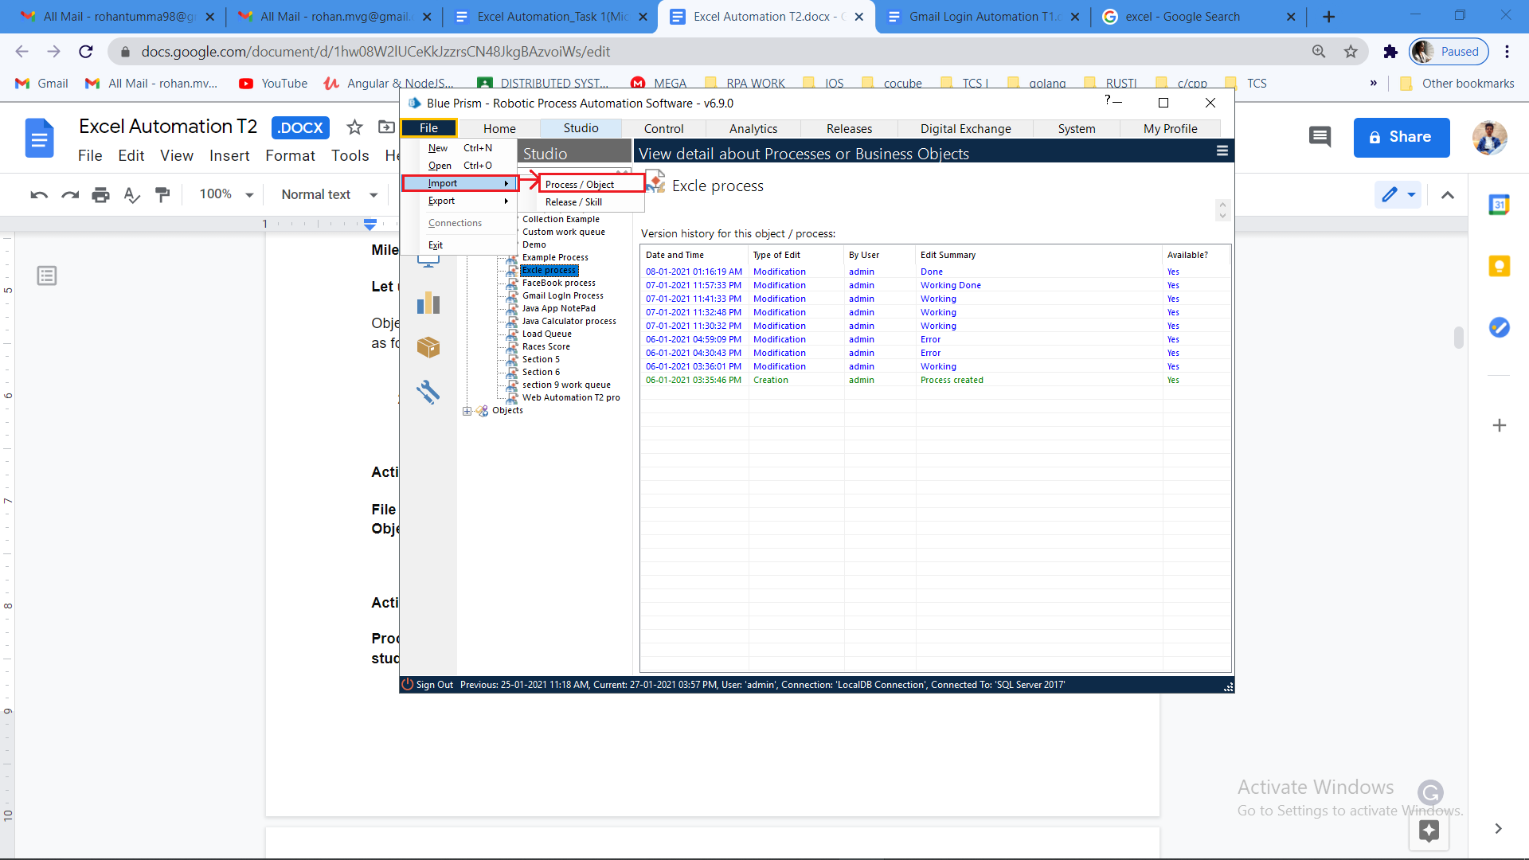

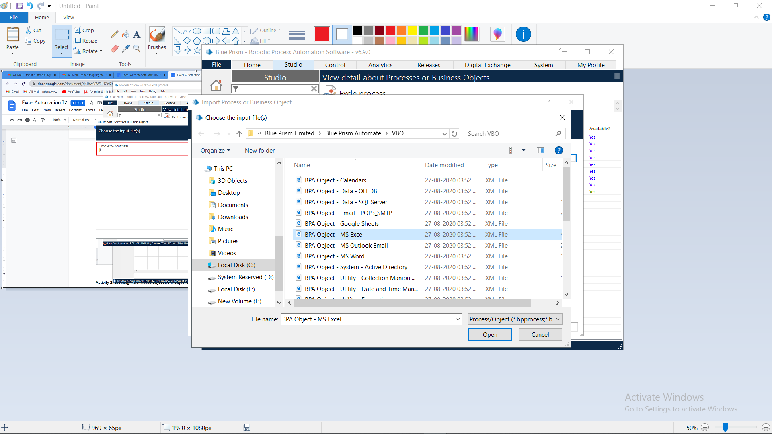

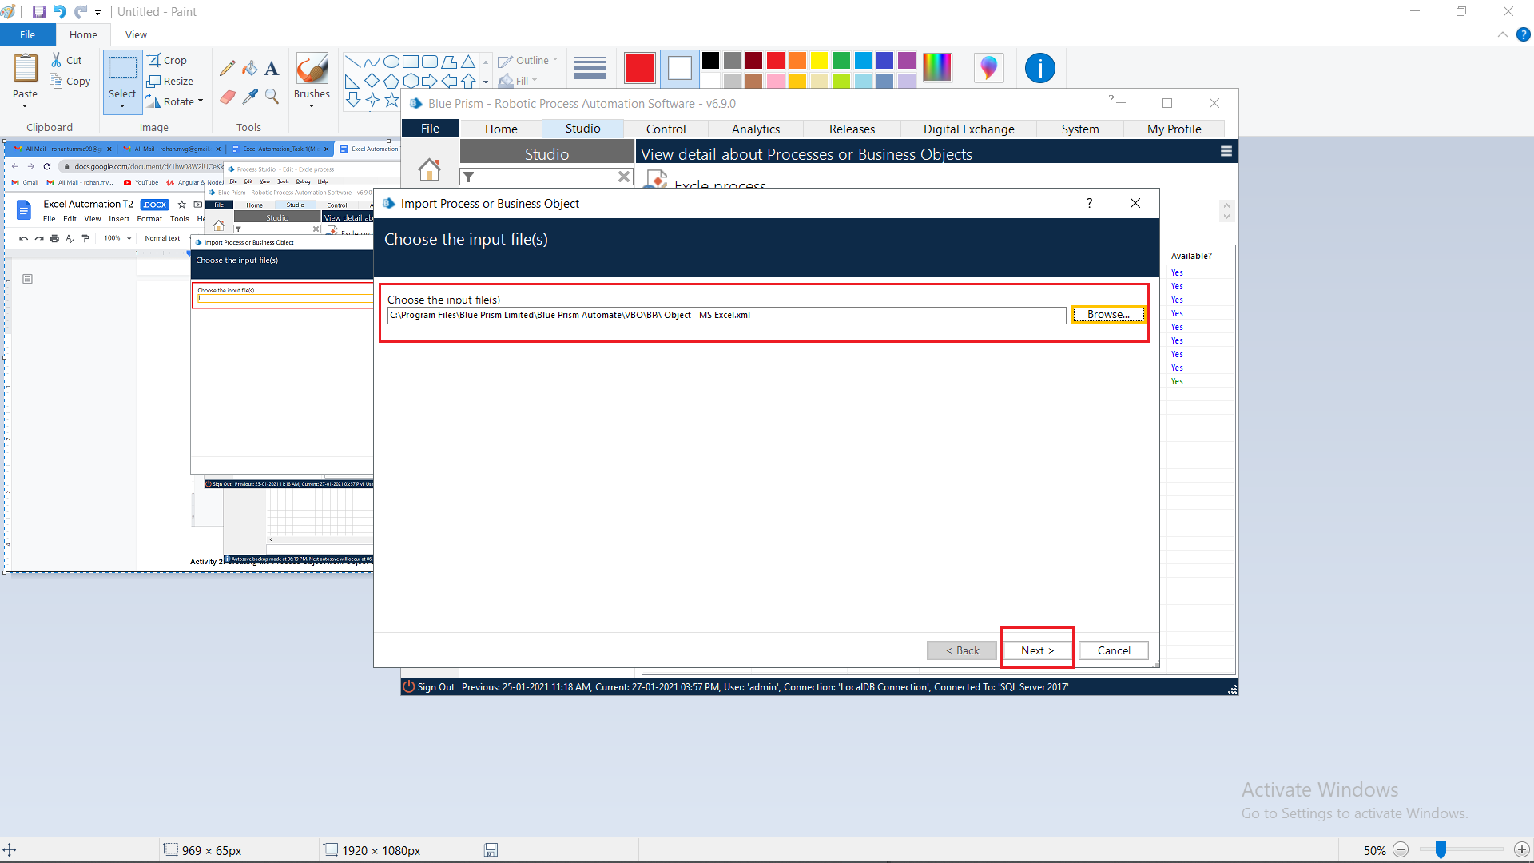

**8.2.2 Activity 2: Creating the Process Object from Object Studio**

Process studio has only the Main page. We can call from the process studio. We use the Process studio for developing and testing.

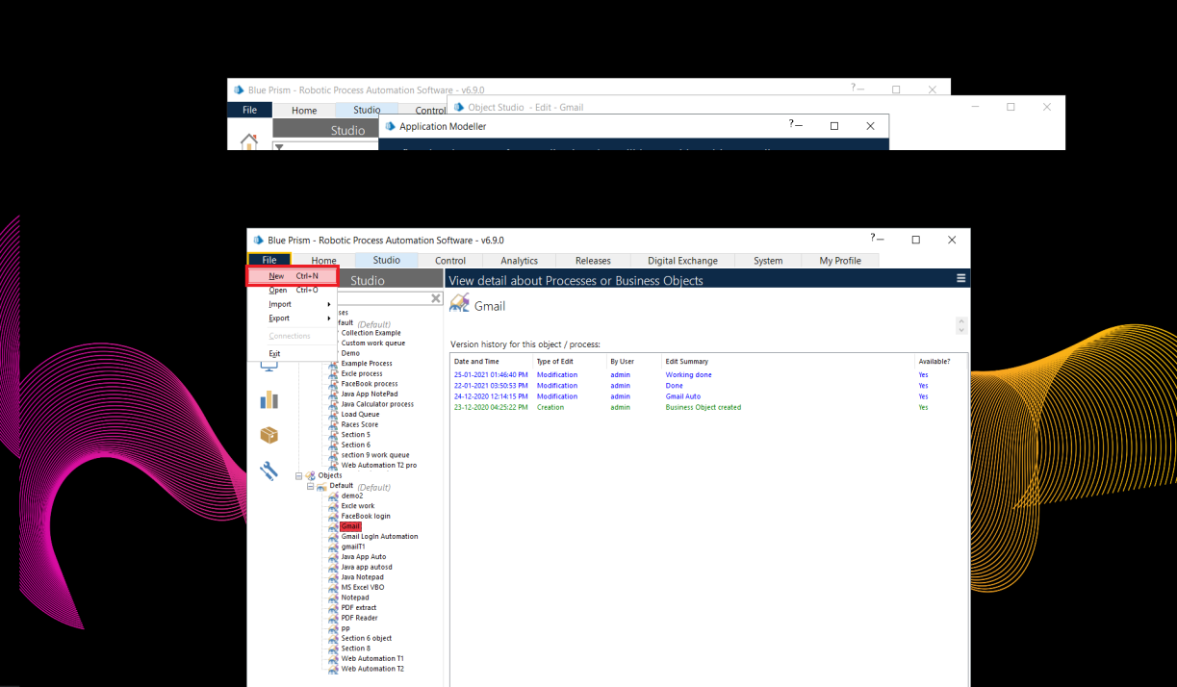

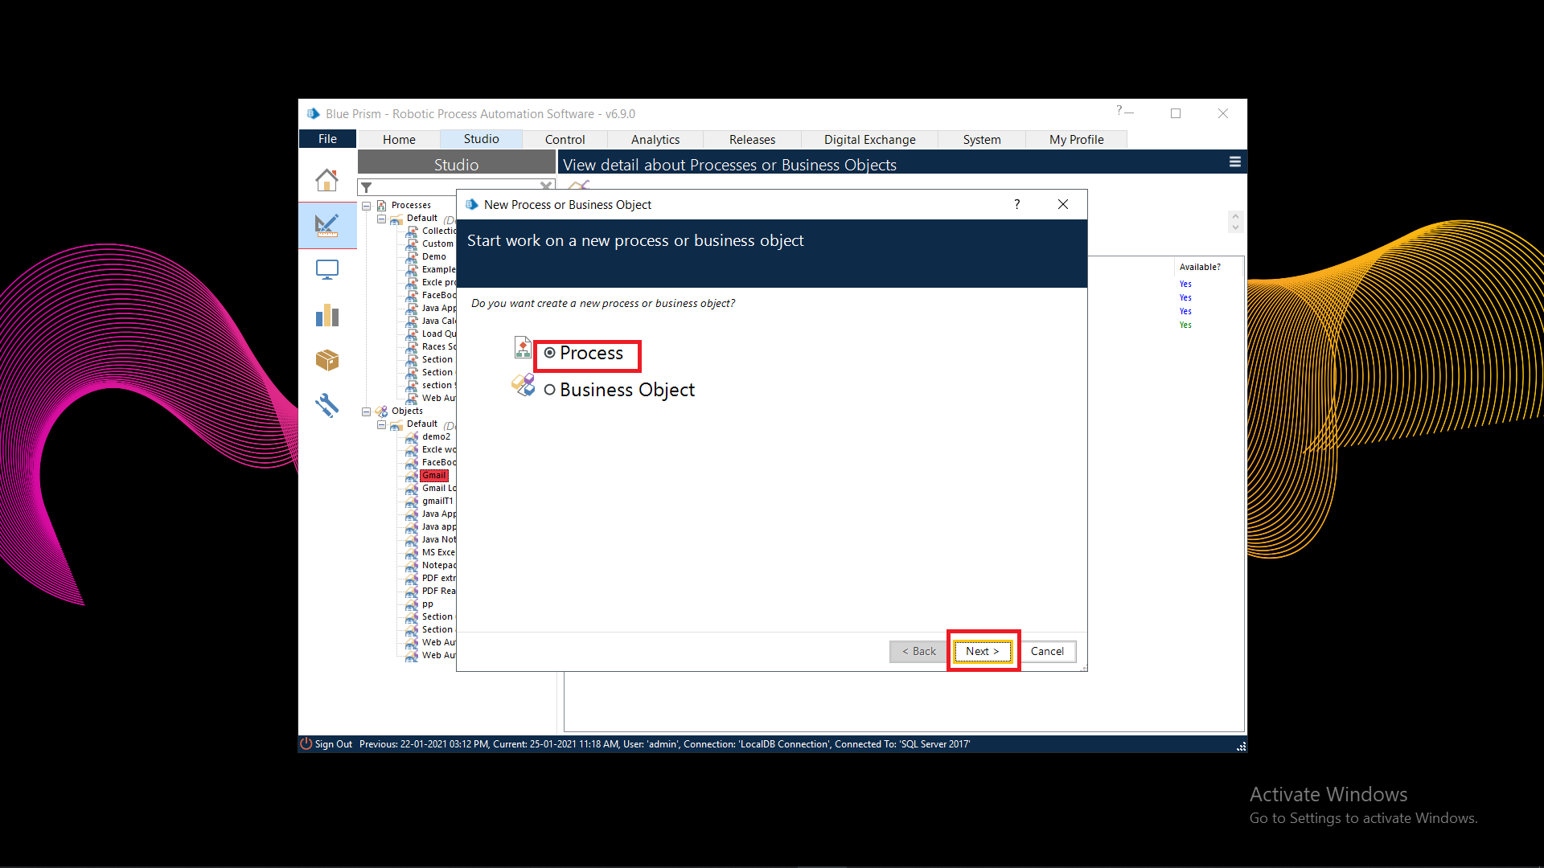

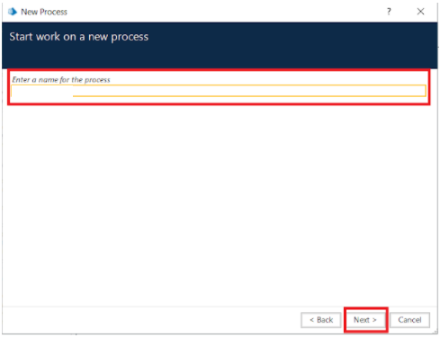

* **Open Created Process Model (HR Payroll Process)**

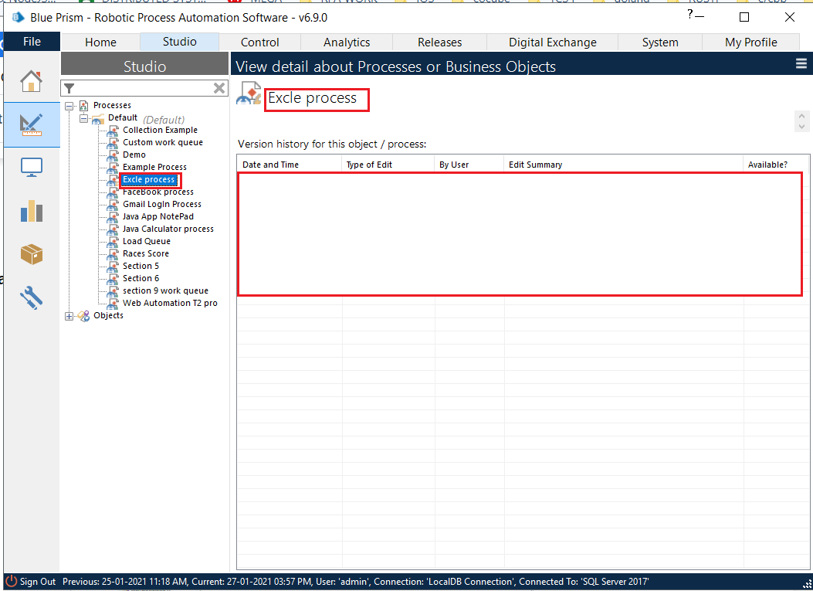

1. Create Action Stage as “Create Instance” (Business Object = MS Excel VBO; Action = Create Instance).
   1. Click on the Outputs tab
      * Create Data Item, type = number, name = “handle”. Drag it into the Store In column.
      * Click on ok.

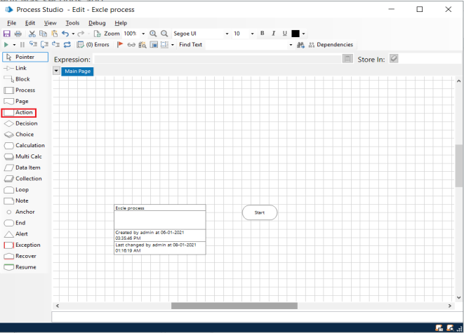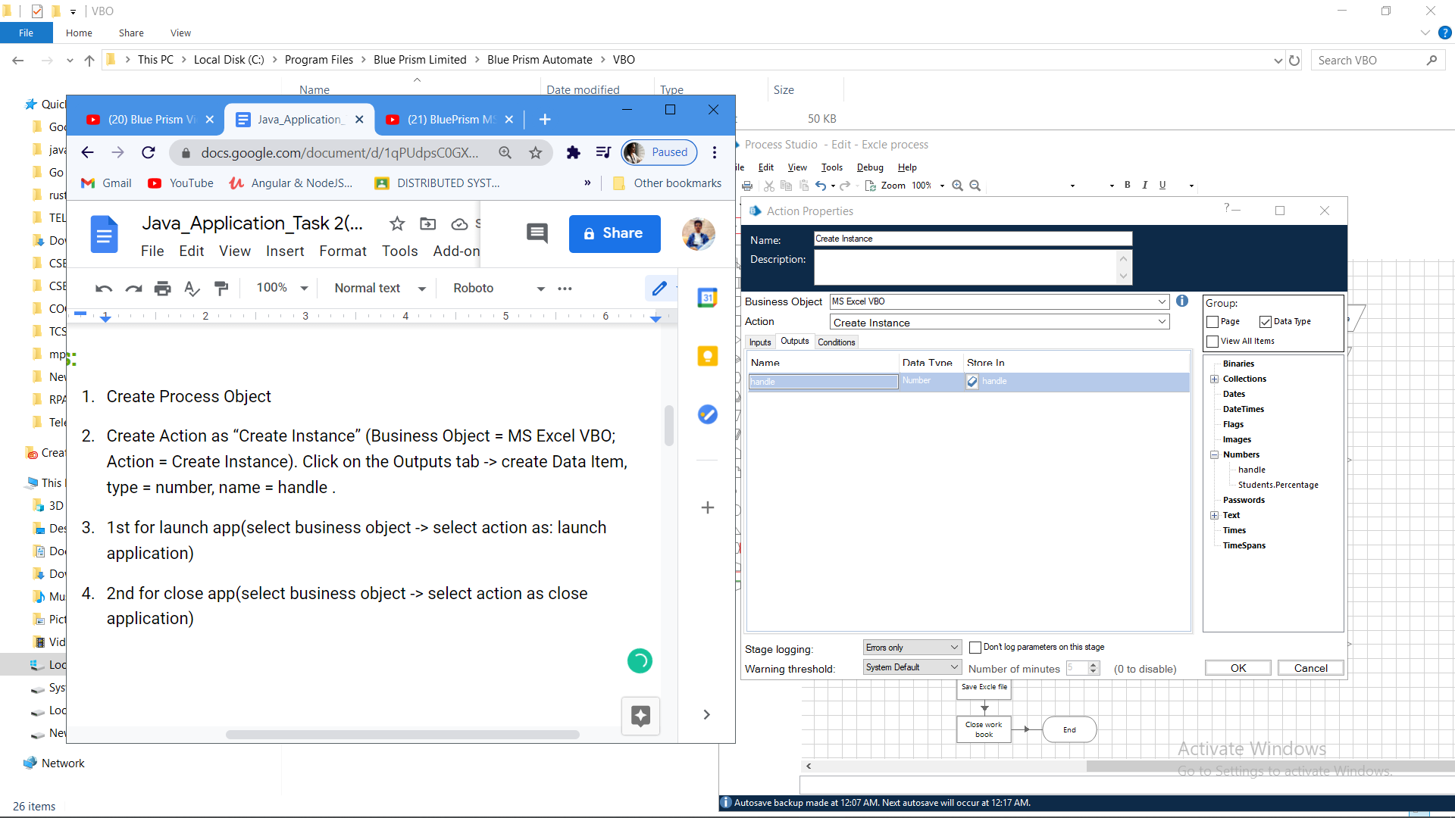

1. Create Action Stage as “Open Excel file” (Business Object = MS Excel VBO; Action = Open WorkBook).
   1. Click on the Inputs tab
      * Drag “handle” data item into handle Valuecolumn.
      * Set file path of excel file in File Name Value column

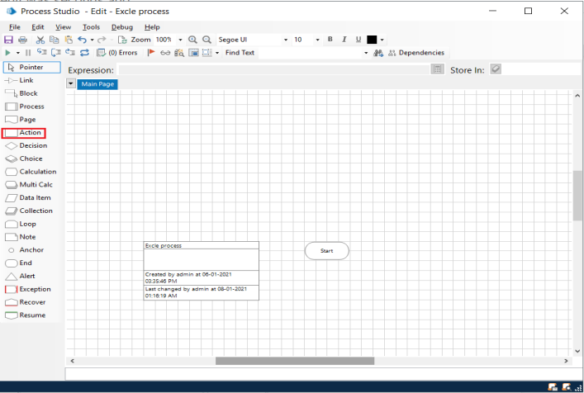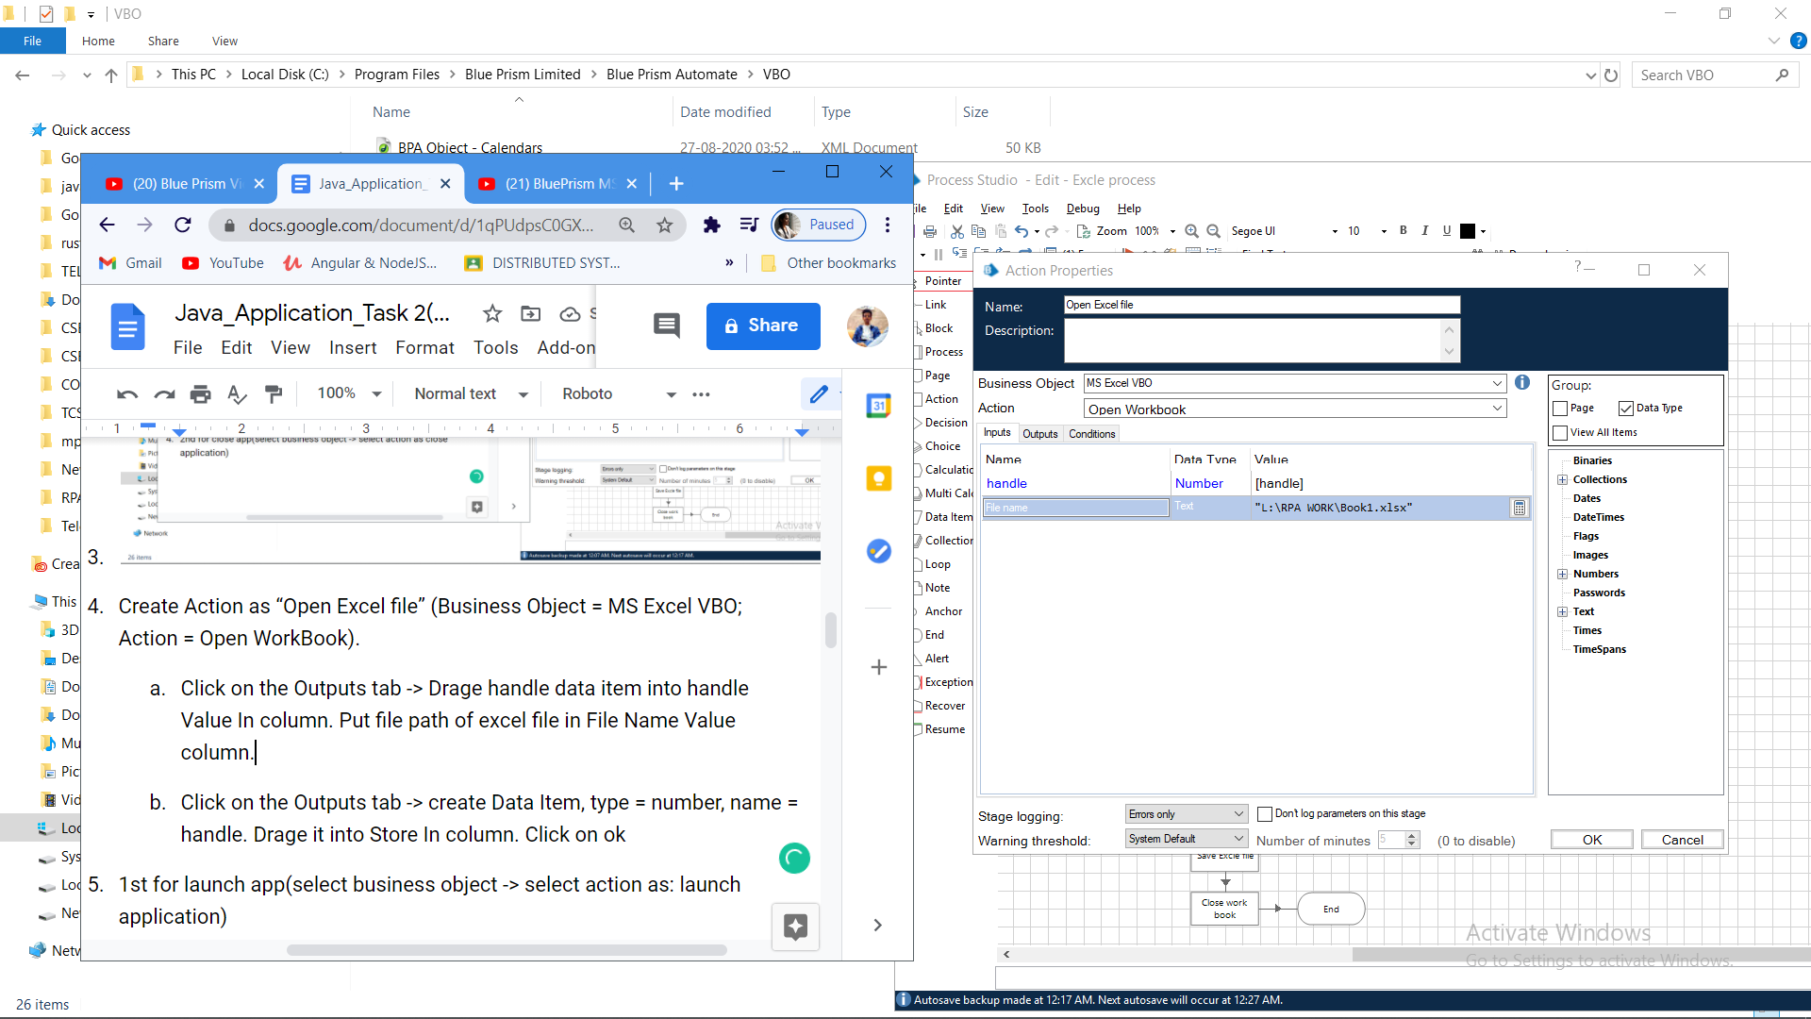

* 1. Click on the Outputs tab
     + Create Data Item, type = Text, name = “WorkBook Name”. Drag it into the Store In column. Click on OK.

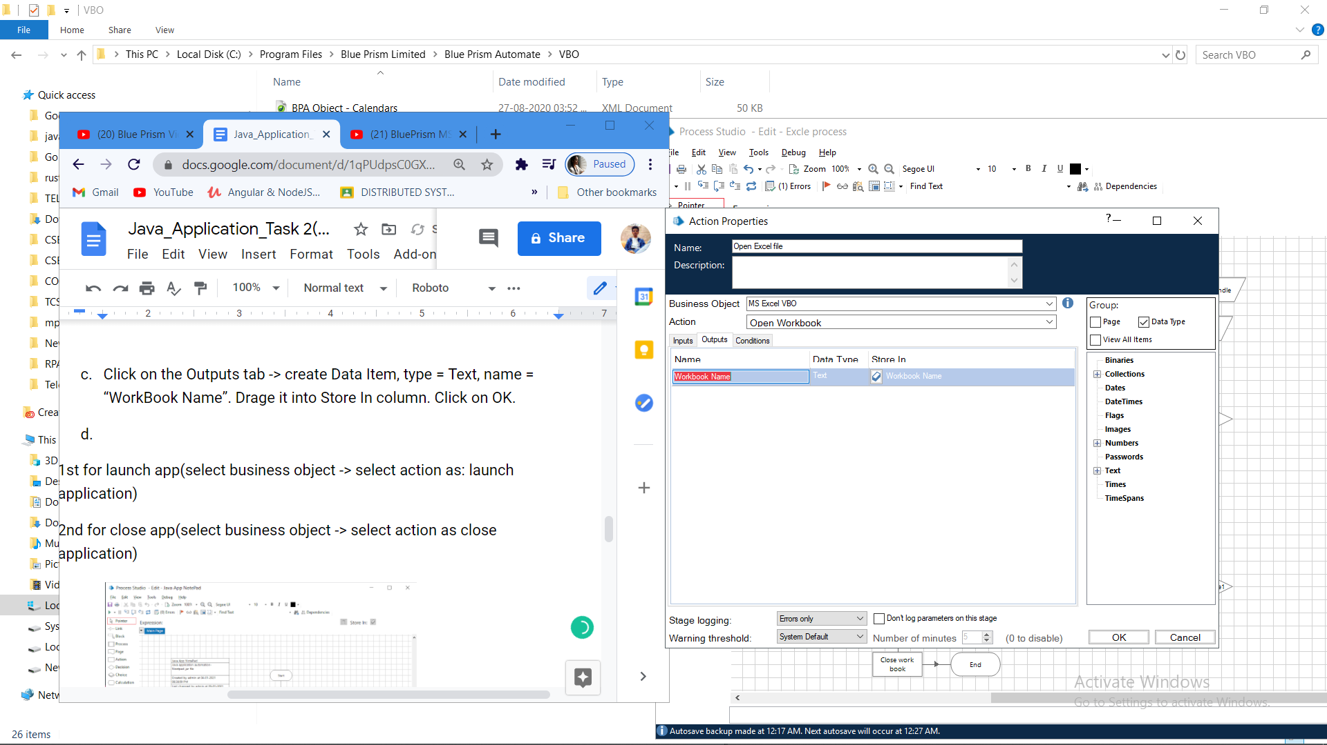

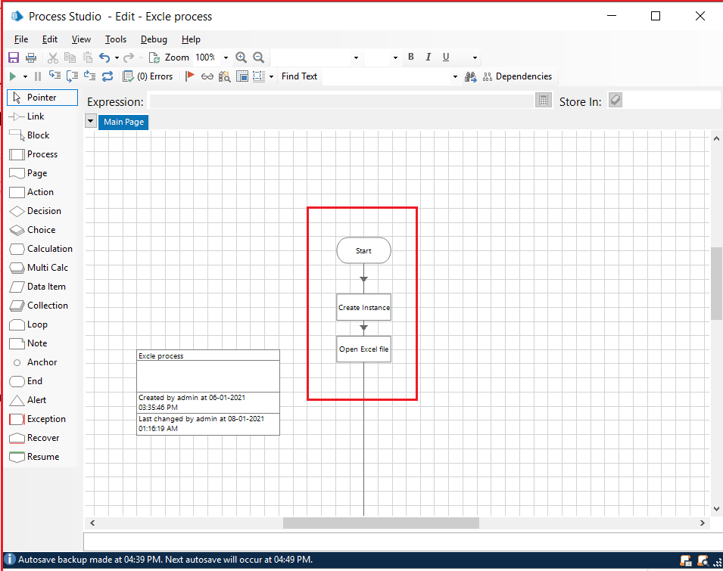

1. Create Action as “Get to collection” (Business Object = MS Excel VBO; Action = Get WorkBook As Collection).
   1. Click on the Inputs tab
      * Drag “handle” data item into handle Value column.
      * Drag “Workbook Name” data item into the Workbook Name Value Column.

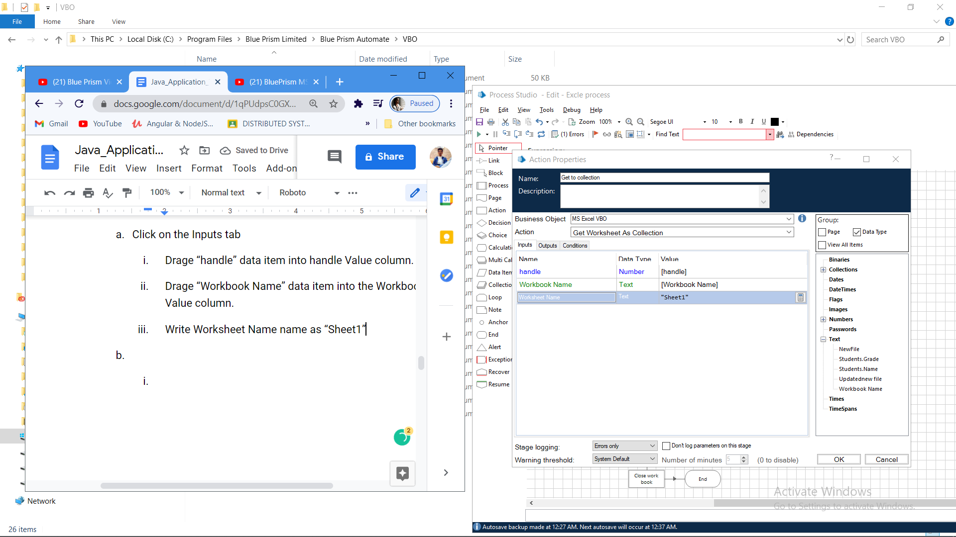

* + - Write Worksheet name as “Sheet1”.
  1. Click on the Outputs tab
     + Create Collection as “Employee”, with the following fields.
     + Use Add Button to add fields in collection.

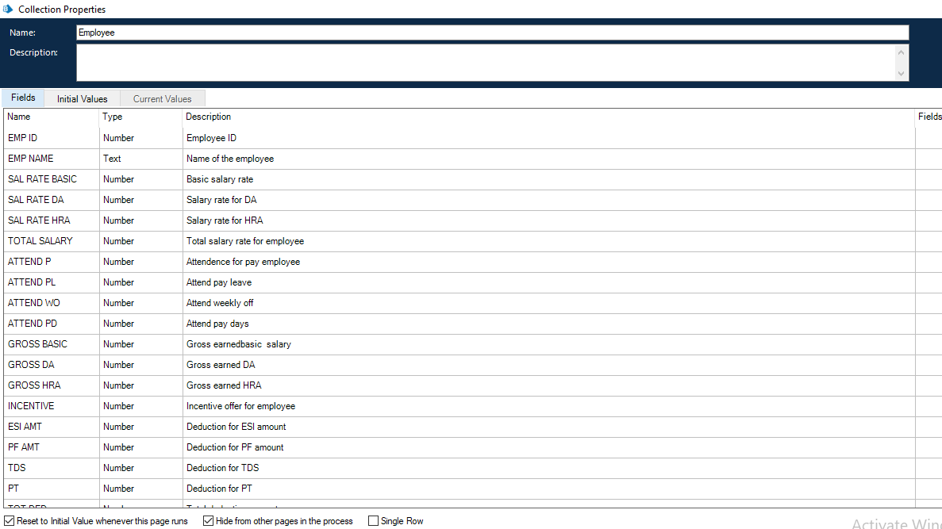

1. Drag Loop module, Drag Multi Calculation module. Connect loop start with Multi Calc stage. Open Multi Calculation Properties and create the following fields.
   * [Employee.SAL RATE BASIC]*0.1
   * ([Employee.SAL RATE BASIC+Employee.SAL RATE DA])*0.3
   * [Employee.SAL RATE BASIC+Employee.SAL RATE DA+Employee.SAL RATE HRA]
   * [Employee.ATTEND P]+[Employee.ATTEND PL]+[Employee.ATTEND WO]
   * ([Employee.SAL RATE BASIC]*[Employee.ATTEND PD])/31
   * ([Employee.SAL RATE DA]*[Employee.ATTEND PD])/31
   * ([Employee.SAL RATE HRA]*[Employee.ATTEND PD])/31
   * [Employee.GROSS BASIC]+ [Employee.GROSS DA]+ [Employee.GROSS HRA]+ [Employee.INCENTIVE]
   * [Employee.TOTAL GROSS]*0.0075
   * ([Employee.GROSS BASIC]+ [Employee.GROSS DA])*0.12
   * [Employee.ESI AMT]+[Employee.PF AMT]+[Employee.TDS]+[Employee.PT]
   * [Employee.TOTAL GROSS]-[Employee.TOT DED]

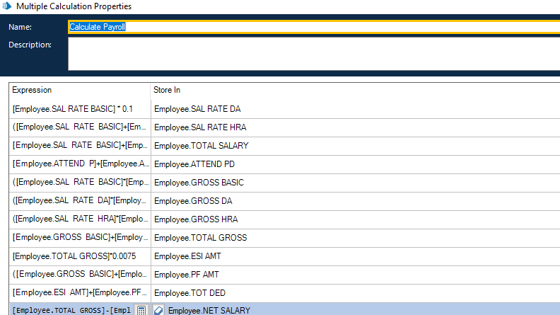

1. Create Action Stage as “Write collection” (Business Object = MS Excel VBO; Action = Write Collection).
   1. Click on the Inputs tab
      * Drag “handle” data item into handle Value column.
      * Drag “WorkBook Name” data item into the Workbook Name Value column.
      * Drag “Employee” Collection into the Collection Value column.
      * Write Worksheet name as “Sheet1”.
      * Write Cell Reference as “A1”.
      * Set Include Column Names as True.

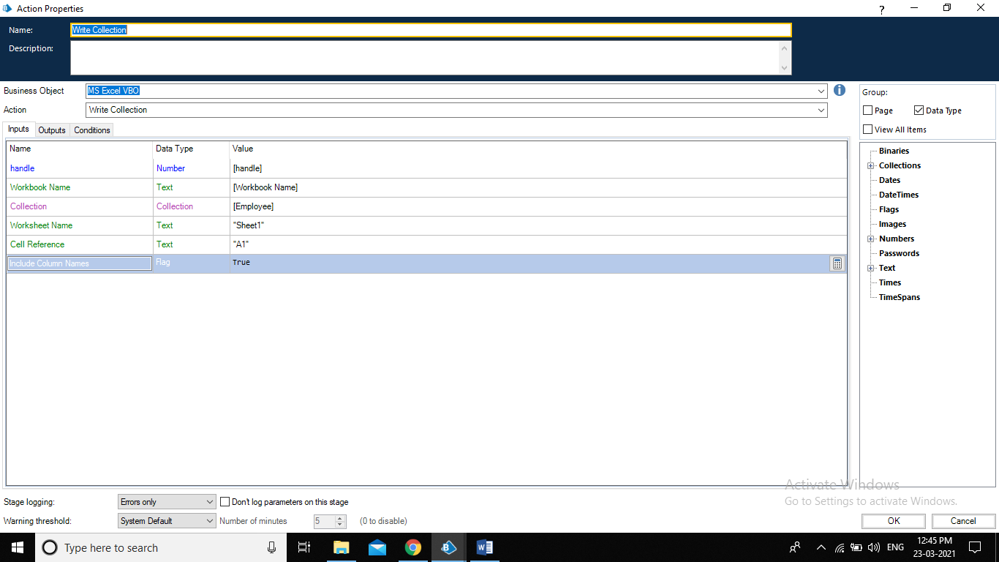

1. Create Action Stage as “Save Excel file” (Business Object = MS Excel VBO; Action = Save Workbook).
   1. Click on the Inputs tab.
      * Drag “handle” data item into handle Value column.
      * Drag “WorkBook Name” data item into the Workbook Name Value column.
2. Create Action Stage as “Close workbook” (Business Object = MS Excel VBO; Action = Close Current WorkBook).
   1. Click on the Inputs tab
   2. Drag “handle” data item into handle Value column.
   3. Do connections as follows.
   4. Input Excel file data.

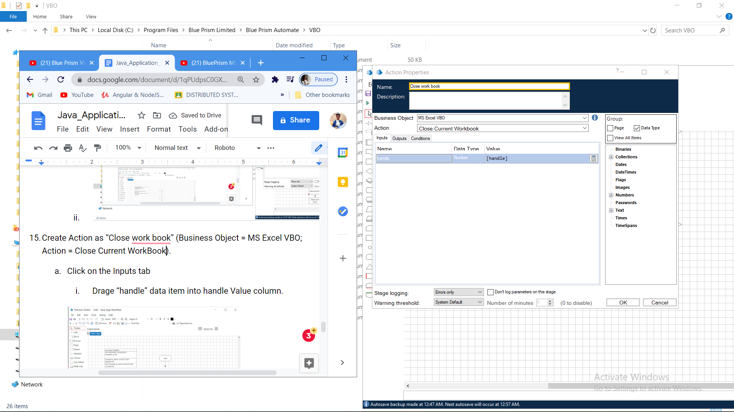

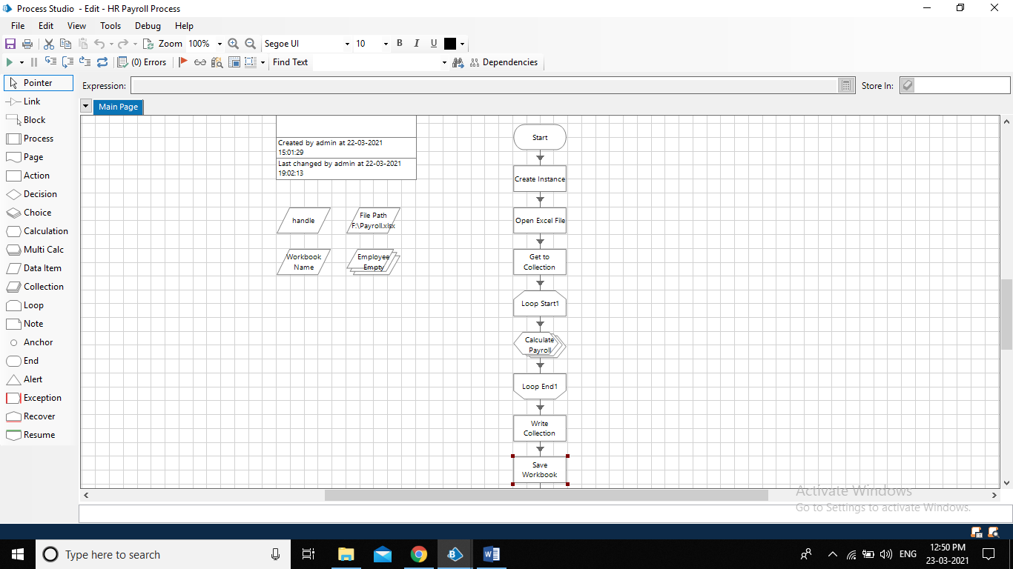

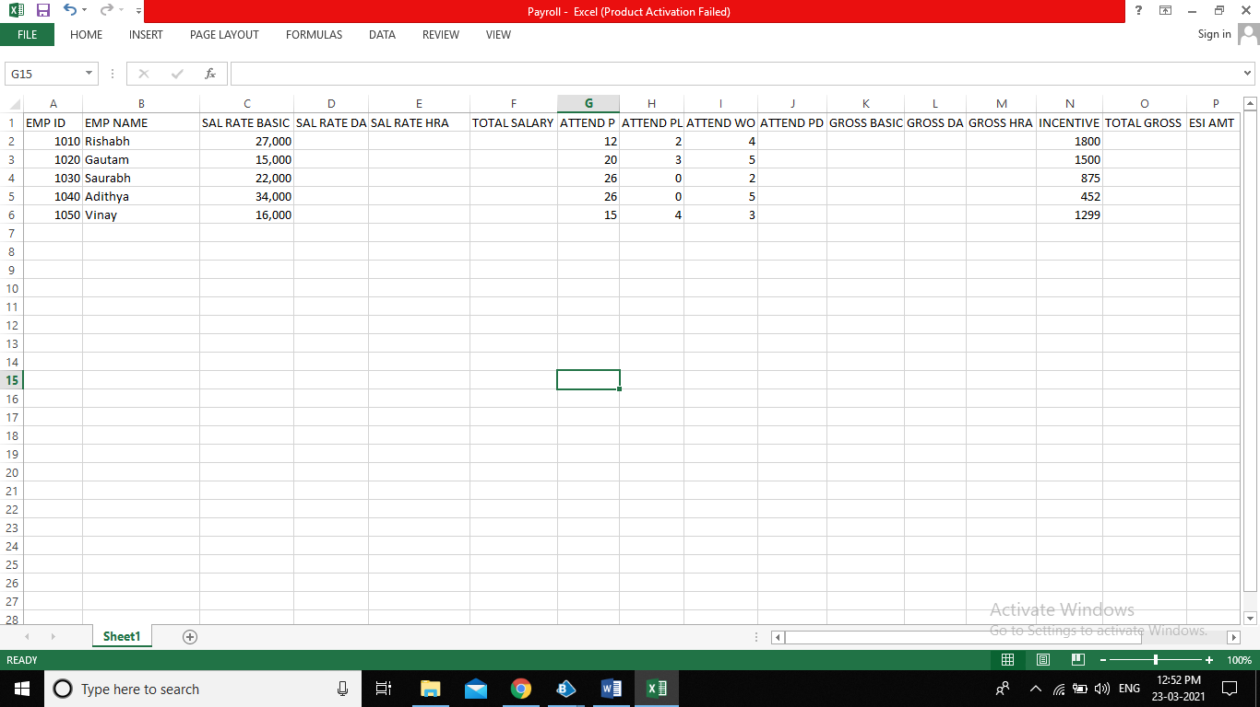

**8.2.3 Activity 3: Testing the Process Object from Object Studio**

Click on the Main Page, click on the Green play button to run the ‘Excel Process’ Process object. It shows COMPLETED when there is no error or no failure in the object.

Click on the Main Page, click on the Reset button to reset the cache for rerun the process object as fresh.

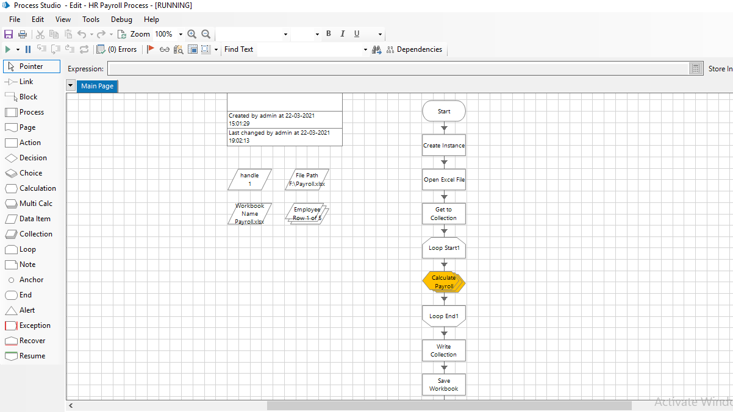

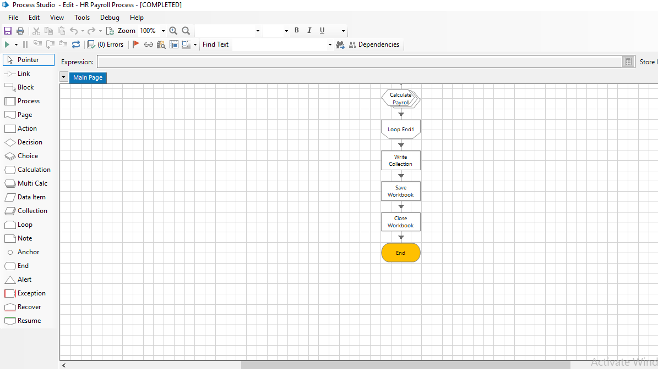

**8.3 Output Excel file.**

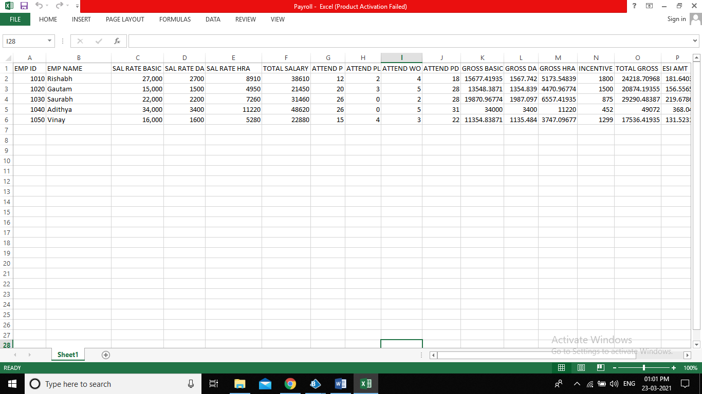

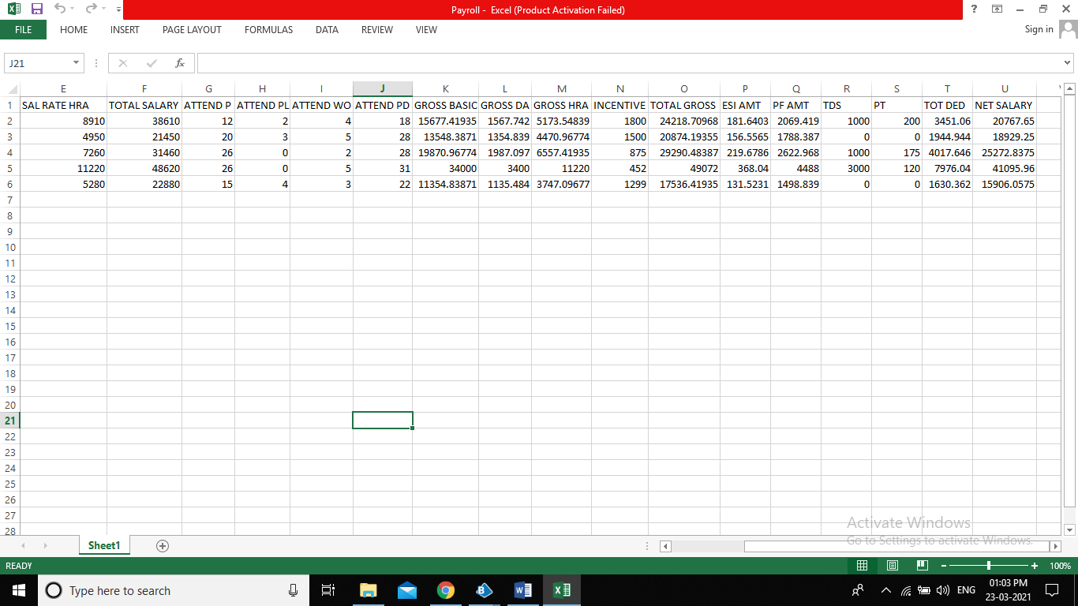

**8.4 Conclusion**

As RPA brings more technologically-advanced solutions to businesses around the world, operating models that adopt automation, whether in-house or offshored, will cut costs, drive efficiency and improve quality.